DEEP LEARNING FOR MALARIA DIAGNOSIS

SK.LATEEF1, P. YOGENDRA BABU², K. DINESH³,

U. VIJAY KUMAR⁴
1, 2, 3Student, Department of CSE(AI), Narasaraopeta Engineering College, Narasaraopeta, Palnadu (D.T) A.P, India
4Assistant Professor, Department of CSE(AI), Narasaraopeta Engineering College, Narasaraopeta, Palnadu (D.T) A.P, India

shaiklateef053@gmail.com¹, yogisky605@gmail.com², liquidlava123@gmail.com³.
@gmail.com¹

- ABSTRACT- Malaria is a female Anopheles mosquito-borne disease that transmits a motile infective form to the host body, bacteria reproduce asexually in the blood cells. The typical symptoms of malaria are fever, headache, tiredness, and vomiting. In severe cases, it may lead to coma and death. In our research, we employed deep neural networks to discern the presence of the malaria virus within human blood cells. Traditional malaria detection techniques require experts to test blood cells under a microscope. The scarcity of proficient technicians and the lack of essential equipment and infrastructure contribute to misdiagnoses, ultimately elevating mortality rates. Early research has shown detection using Machine Learning techniques like Support Vector Machine (SVM), which is tedious and requires hand-engineered feature extraction to train data. And the results were not up to the mark. The proposed method in this research shows a system with end-to-end automated models using a deep neural network that performs feature extraction and classification using blood smear cell images. The dataset utilized for this investigation was sourced from the National Institute of Health (NIH) Malaria Dataset. Models are evaluated based on accuracy, precision, recall, and F1- score. Data Pre-processing techniques like segmentation and normalization are applied to maximize the model performance. In this research, two deep Convolutional Neural Networks, VGG-19, and ResNet-50 are experimented on to analyze and compare the best-performing model on the malaria dataset [25]. Our results showed that the ResNet-50 outperforms the VGG-19 by achieving an accuracy of 97 percent [15].

KEYWORDS: Deep Learning, Tensor flow, Convolution, Pooling, RelU, epic

INTRODUCTION

Malaria, a mosquito-borne disease caused by the Plasmodium parasite, affects millions of people annually, resulting in significant mortality rates. Diagnosis traditionally relies on light microscopy, which faces challenges due to a shortage of skilled technicians in affected regions, leading to delays and inaccuracies in diagnosis. This inaccurate diagnosis contributes to higher mortality rates, drug resistance, and unnecessary economic burdens.

In response to these challenges, our research is dedicated to crafting a highly accurate malaria diagnosis model, aiming to diminish the reliance on skilled technicians. The goal is to provide a reliable alternative for routine high-quality diagnosis, especially in areas lacking easy access to healthcare [8].

The proposed solution involves leveraging deep learning, specifically Convolutional Neural Networks (CNNs), for malaria diagnosis. Unlike traditional machine learning methods, deep learning models, such as RESNET-50 and VGG-19, are scalable, reliable, and exhibit higher accuracy rates. CNNs, in particular, have proven effective in various computer vision tasks.

The research aims to answer two key questions:

Model Comparison: Evaluate the performance of two CNNs, RESNET-50 and VGG-19, on the malaria dataset to determine which one performs better for diagnosis,

Effect of Pre-Processing: Investigate the impact of pre-processing techniques, such as data augmentation, stain normalization, and standardization, on the performance of CNNs for malaria diagnosis.

Proposing automated image analysis software has been instrumental in overcoming the limitations of conventional microscopy, offering a faster and more efficient diagnosis process. The ultimate objective is to enhance early and accurate diagnosis, leading to prompt treatment, thereby saving lives and reducing the global burden of malaria.

LITERATURE SURVEY

3.1 Malaria and its Diagnosis
Malaria is a parasite-borne illness carried by mosquitoes and poses a severe danger to global health. An estimated 300–500 million cases of malaria occur annually, with 1.5–2.7 million deaths, underscoring the importance of the disease [2]. Light microscopy-based conventional diagnostic techniques are acknowledged and entail the study of stained blood smears. However, there are problems with these methods, such as the dependence on skilled experts. This dependence on manual microscopy leads to delays in obtaining accurate diagnoses, proving to be inefficient and contributing to higher mortality rates in regions with limited access to healthcare [5]. In this context, the significance of efficient and automated diagnostic tools is underscored, opening the door for further research into state-of-the-art techniques such as deep learning for malaria diagnosis.

3.2 Machine Learning Applications in Health Care
In the sphere of healthcare, the use of computer-aided diagnostic instruments powered by machine-learning algorithms has largely supplanted conventional diagnostic techniques. The motivation behind this shift stemmed from the potential for enhanced accuracy and efficiency in medical diagnosis. Previous research endeavors have thoroughly studied a range of machine learning methods, including logistic regression, Bayesian learning, support vector machines, and k-nearest neighbor algorithms, to solve the issues associated with malaria detection. While achieving notable results, challenges have surfaced with manually constructed feature extraction methods. The healthcare sector is increasingly turning to deep learning to address these challenges, considering it a more adaptable and efficient approach. With the promise of improved diagnostic efficiency and accuracy, machine learning (ML) applications have replaced traditional diagnostic techniques in the healthcare industry [7]. To surmount the challenges in malaria diagnosis, we introduced machine learning techniques, including support vector machines, k-nearest neighbor algorithms, logistic regression, and Bayesian learning. On the other hand, the shortcomings of manually created feature extraction methods account for the failure in certain cases. The inability of these approaches to fully capture the intricacy of medical data resulted in less-than-ideal outcomes [16].

3.3 Deep Learning Applications in Health Care
The field of medical image analysis has witnessed significant advancements through the application of deep learning, particularly with Convolutional Neural Networks (CNNs). These networks have substantially enhanced diagnostic accuracy and automated complex tasks [3]. This literature review acknowledges deep learning's broad use in the medical field and highlights how it can be utilized to assess pathology slides and X-rays, among other medical pictures. However, because deep learning models are black-box, making it difficult for physicians to understand that, questions have been raised about their interpretability and simplicity in medical settings [4]. Implementation must be done responsibly because of ethical issues, such as patient privacy and possible biases [6]. The goal of ongoing research is to overcome these issues and strike a compromise between upholding ethical norms, transparency, and trust while utilizing deep learning's efficiency in the healthcare industry [9].

MODEL SELECTION

4.1 VGG - 19
Oxford's Visual Geometry Group produced a 19-layer deep Convolutional Neural Network (CNN) called VGG-19, a derivative of the VGG model [23].

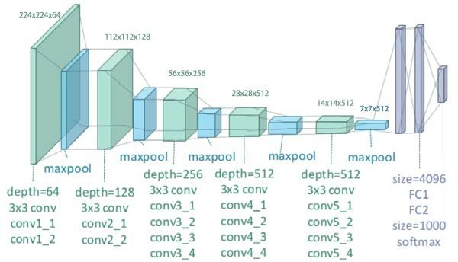

Fig1: VGG-19

4.2 Transfer Learning
Transfer learning allows the application of knowledge from pre-trained models to address specific problem sets [42]. Rather than beginning from zero, we leveraged models built on large-scale datasets such as Image-Net (100,000 data points). This study highlights the effectiveness of transfer learning, which is beneficial in several picture categorization studies [10]. Specifically, we employed Convolutional Neural Networks (CNNs) as feature extractors, which had undergone pre-training on extensive datasets like VGG-19 and ResNet-50. Compared to conventional techniques, this approach excels as it acknowledges the models' ability to generalize information from diverse datasets. [11].

4.3 ResNet-50
Deep neural network training revolutionized when VGG-19, a Convolutional Neural Residual Network (ResNet), appeared as an answer to the vanishing gradient problem. ResNet, winner of the 2015 ImageNet competition, improved results and lessened the gradient problem with its skip connection strategy, paving the way for models such as ResNet50. Using ResNet50 and transfer learning, this study freezes the first blocks and uses fine-tuning in addition to pre-processing methods. The five stages of the ResNet-50 model, which has 25 million trainable parameters, include identity and convolution blocks.

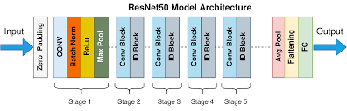
Fig 2: ResNet-50

In binary image classification, the preference leans towards sigmoid activation rather than softmax. Accuracy and Loss are two evaluation metrics assessed in batches of size 64 using the RMS Prop optimizer and binary cross-entropy during both training and validation.

4.4 Keras
It is a Python module for deep learning that operates on top of the TensorFlow library.

PROPOSED MODEL

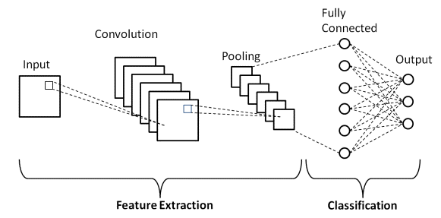

Fig 5.1: Model

Objective
This proposed Convolution Neural Network (CNN) model aims to address the problem of image classification, in the context where the objective is to classify images into predefined categories [1]. The primary goals are to enhance classification accuracy, mitigate over-fitting, and strengthen the model's capability to discern intricate patterns within images [18].

Architecture Overview

The proposed CNN consists of three convolutional layers, each followed by a Rectified Linear Unit (ReLU) activation function. Max pooling is implemented after each convolutional layer to downsample the feature maps. The final layer is a fully connected layer with softmax activation for classification [12], [13].

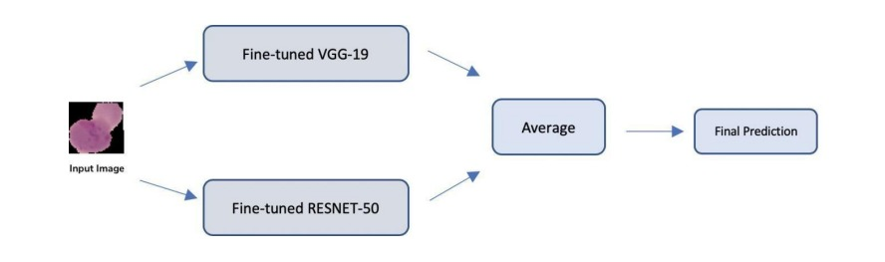

Fig 5.2: Model approach

Key Components

An attention mechanism is integrated after the second convolutional layer to enhance the model's focus on affected regions. This attention mechanism allows the model to prioritize relevant features during the learning process. [14]

Hyper-parameters

Key hyper-parameters in ResNet-50 include a learning rate of 0.001 and set lr = 1e – 4, a batch size of 64, and dropout with a rate of 0.3 to prevent over-fitting [20]. These values were selected through experimentation and grid search [26].

Training Procedure

The model was trained on a diverse dataset of 27,557 images, of which 13,778 are infected and 13,779 are non-infected. We merged files of non-infected and parasitized images and labeled them as healthy and malaria for the respective files [11]. The dataset is divided into three sets for training, validation, and testing [17]. 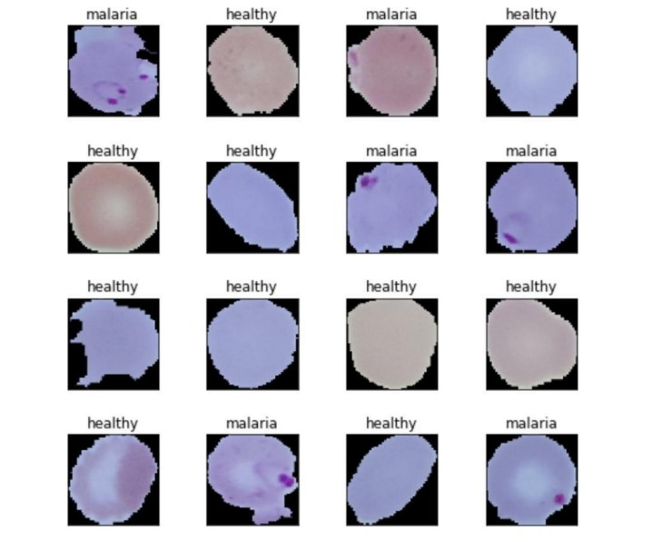

Fig 5.3: Malaria Dataset

The ratio of the train to validation to test is 63:7:30. We preferred to take only 63% of the dataset as training to avoid high computational intensity due to the large dataset [24], [22].

Validation and Testing

The model's performance is evaluated on a separate validation set, and the metrics include accuracy, precision, recall, and F1 score [21]. A test set is used for final evaluation [14].

RESULT ANALYSIS

Leveraging transfer learning and fine-tuning on a malaria dataset, we utilize pre-trained Convolutional Neural Networks (CNNs) to investigate human red blood cell smear images to identify them as healthy or infected [19]. Results show that pre-processing methods such as scaling, stain standardization, and normalization have little effect on the performance of VGG-19 and ResNet-50. On the other hand, data augmentation shows encouraging outcomes. ResNet-50, on the other hand, outperforms VGG-19, which achieves 96.24% accuracy after fine-tuning, with a noteworthy 97.09% accuracy with data augmentation. Transfer learning works well, demonstrating the superiority of ResNet-50 with an accuracy of 97.09%. An ensemble model obtained 96.76% accuracy, compared to the previous state-of-the-art ResNet accuracy of 95.7%.

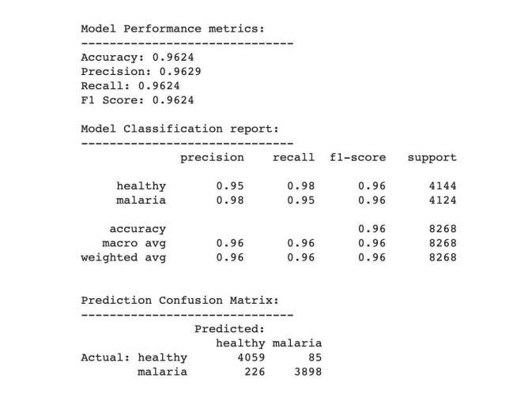

Fig 6.1: A fine-tuned model for both VGG-19 and ResNet-50

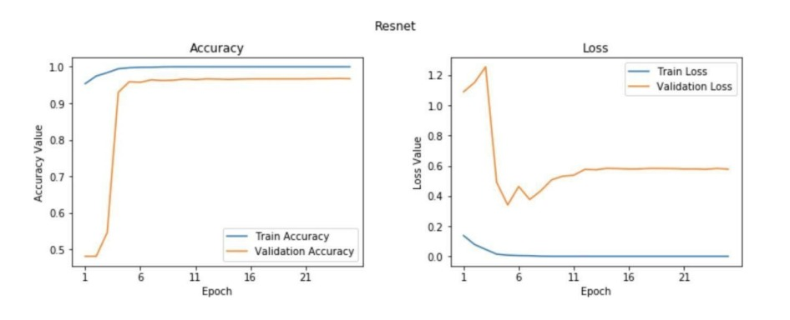Fig 6.2: Accuracy plot ResNet-50

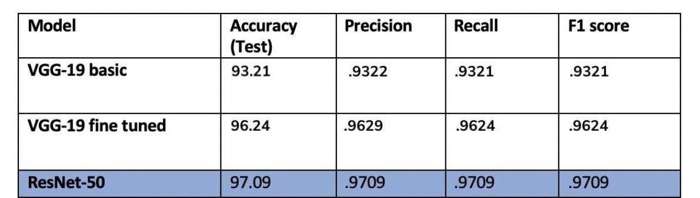

Fig 6.3: Model Performance

CONCLUSION

In this paper, we investigated how well end-to-end deep-learning neural networks can improve the classification of malaria diagnoses. Preprocessing methods, including staining, normalization, and standardization, showed no significant impact on performance, as indicated by our research. On the other hand, data augmentation produced favorable results that significantly boosted the model's performance. VGG-19 and ResNet-50 were compared and built from scratch via transfer learning with hyper-parameter adjustment. The results showed that ResNet-50 performed better, with an accuracy of 97.09%. We will now shift our focus to network architecture optimization to pinpoint important performance aspects and improve model performance via more testing and hyper-parameter tuning.

REFERENCES

[1] Sumit Saha. A Comprehensive Guide to Convolutional Neural Networks. https://towardsdatascience.com/ a-comprehensive-guide-to-convolutional-neural-networks-the-eli5-way-3bd2b1164a53, 2018.

[2] Andrej Trampuz, Matjaz Jereb, Igor Muzlovic, and Rajesh M. Prabhu. Clinical review: Severe malaria. Critical Care, 7(4):315–323, Aug 2003.

[3] WHO. WHO | This year's World Malaria Report at a Glance. https://www.who. int/malaria/media/world-malaria-report-2018/en/, 2018.

[4] Andrej Karpathy. CS231n Convolutional Neural Networks for Visual Recognition. http://cs231n.github.io/convolutional-networks/, 2018.

[5] Noppadon Tangpukdee, Chatnapa Duangdee, Polrat Wilairatana, and Srivicha Krudsood. Malaria diagnosis: A brief review, 2009.

[6] T. Hänscheid. Current strategies to avoid misdiagnosis of malaria. Clinical Microbiology and Infection, 9(6):497–504, Jun 2003.

[7] John A. Quinn, Rose Nakasi, Pius K. B. Mugagga, Patrick Byanyima, William Lubega, and Alfred Andama. Deep Convolutional Neural Networks for Microscopy-based Point of Care Diagnostics. pages 1–12, 2016.

[8] Dev Kumar Das, Madhumala Ghosh, Mallika Pal, Asok K. Maiti, and Chandan Chakraborty. Machine learning approach for automated screening of malaria parasite using light microscopic images. Micron, 45:97–106, Feb 2013.

[9] Dev Kumar Das, Madhumala Ghosh, Mallika Pal, Asok K. Maiti, and Chandan Chakraborty. Machine learning approach for automated screening of malaria parasite using light microscopic images. Micron, 45:97–106, Feb 2013.

[10] Han Sang Park, Matthew T. Rinehart, Katelyn A. Walzer, Jen-Tsan Ashley Chi, and Adam Wax. Automated Detection of P. falciparum Using Machine Learning Algorithms with Quantitative Phase Images of Unstained Cells. PLOS ONE, [11] K. Sriporn, C.-F. Tsai, C.-E. Tsai, and P. Wang, “Analyzing malaria disease using effective deep learning approach,” Diagnostics, vol. 10, no. 10, p. 744, 2020.

[12] M. P. Horning, C. B. Delahunt, C. M. Bachman, J. Luchavez, C. Luna, L. Hu, M. S. Jaiswal, C. M. Thompson, S. Kulhare, S. Janko, B. K. Wilson, T. Ostbye, M. Mehanian, R. Gebrehiwot, G. Yun, D. Bell, S. Proux, J. Y. Carter, W. Oyibo, D. Gamboa, M. Dhorda, R. Vong promek, P. L. Chiodini, B. Ogutu, E. G. Long, K. Tun, T. R. Burkot, K. Lilley, and C. Mehanian, “Performance of a fully-automated system on a who malaria microscopy evaluation slide set,” Malaria journal, vol. 20, no. 1, pp. 1–11, 2021.

[13] Z. Yang, H. Benhabiles, K. Hammoudi, F. Windal, R. He, and D. Collard, “A generalized deep learning-based framework for assistance to the human malaria diagnosis from microscopic images,” Neural Computing and Applications, pp. 1–16, 2021.

[14] H. Yu, F. Yang, S. Rajaraman, I. Ersoy, G. Moallem, M. Poostchi, K. Palaniappan, S. Antani, R. J. Maude, and S. Jaeger, “Malaria screener: a smartphone application for automated malaria screening,” BMC Infectious Diseases, vol. 20, no. 1, pp. 1–8, 2020.

[15] Ali Sharif Razavian, Hossein Azizpour, Josephine Sullivan, and Stefan Carlsson. CNN features off-the-shelf: An astounding baseline for recognition. In IEEE Computer Society Conference on Computer Vision and Pattern Recognition Workshops, pages 512–519. IEEE Computer Society, Sep 2014.

[16] M. Masud, H. Alhumyani, S. S. Alshamrani, O. Cheikhrouhou, S. Ibrahim, G. Muhammad, M. S. Hossain, and M. Shorfuzzaman, “Leveraging deep learning techniques for malaria parasite detection using mobile application,” Wireless Communications and Mobile Computing, vol. 2020, 2020.

[17] R. Bao, N. M. Al-Shakarji, F. Bunyak, and K. Palaniappan, “Dmnet: Dual-stream marker guided deep network for dense cell segmentation and lineage tracking,” in IEEE/CVF International Conference on Computer Vision, 2021, pp. 3361–3370.

[18] A. Hamad, I. Ersoy, and F. Bunyak, “Improving nuclei classification performance in h&e stained tissue images using fully convolutional regression network and convolutional neural network,” in IEEE Applied Imagery Pattern Recognition Workshop (AIPR), 2018, pp. 1–6.

[19] N. P. Nguyen, I. Ersoy, J. Goldberg, F. Bunyak, and T. A. White, "DRPnet: automated particle picking in cryo-electron micrographs using deep regression," BMC Bioinformatics, vol. 22, no. 1, pp. 1–28, 2021.

[20] N. Otsu, "A threshold selection method from gray-level histograms," IEEE Transactions on Systems, Man, and Cybernetics, vol. 9, no. 1, pp. 62–66, 1979.

[21] O. Ronneberger, P. Fischer, and T. Brox, “U-net: Convolutional networks for biomedical image segmentation,” in International Conference on Medical image computing and computer-assisted intervention. Springer, 2015, pp. 234–241.

[22] Ali Sharif Razavian, Hossein Azizpour, Josephine Sullivan, and Stefan Carlsson. CNN features off-the-shelf: An astounding baseline for recognition. In IEEE Computer Society Conference on Computer Vision and Pattern Recognition Workshops, pages 512–519. IEEE Computer Society, Sep 2014.

[23] Princeton University Stanford Vision Lab, Stanford University. ImageNet.

[24] Diederik P. Kingma and Jimmy Lei Ba. Adam: A method for stochastic optimization. In 3rd International Conference on Learning Representations, ICLR 2015 - 72 Conference Track Proceedings. International Conference on Learning Representations, ICLR, Dec 2015.

[25] Kaiming He, Xiangyu Zhang, Shaoqing Ren, and Jian Sun. Deep residual learning for image recognition. In Proceedings of the IEEE Computer Society Conference on Computer Vision and Pattern Recognition, volume 2016-Decem, pages 770–778. IEEE Computer Society, Dec 2016. [26] A. c Bharadwaj Reddy and D. Sujitha Juliet. Transfer learning with RESNET-50 for malaria cell-image classification. In Proceedings of the 2019 IEEE International Conference on Communication and Signal Processing, ICCSP 2019, pages 945–949. Institute of Electrical and Electronics Engineers Inc., Apr 2019.

